***=======================================================***

***Dt : 24/8/2022***

***Execution flow of DemoMethods2.java***

***ClassFiles:***

***Greater.class***

***Smaller.class***

***DemoMethods2.class(MainClass)***

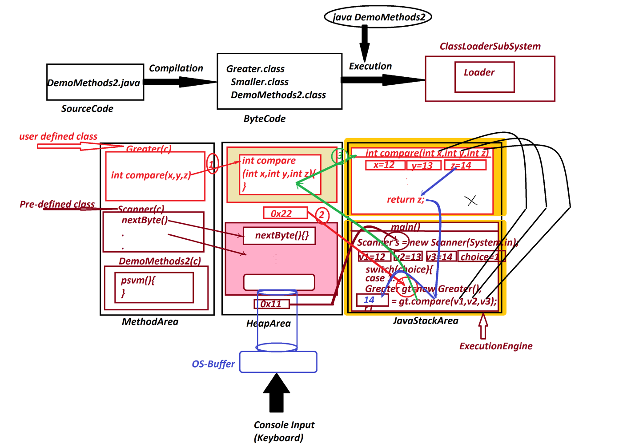

***Note:***

***=>MainClass is loaded onto MethodArea first and then remaining***

***SubClasses are loaded based on their requirement in execution***

***process.***

***===============================================***

***Assignment-1:(Solution)***

***wap to read two integer values and perform the following***

***operations based on user choice:***

***1.add***

***2.sub***

***3.mul***

***4.div***

***5.modDiv***

***import java.util.Scanner;***

***class Addition***

***{***

***int add(int x,int y)***

***{***

***return x+y;***

***}***

***}***

***class Subtraction***

***{***

***int sub(int x,int y)***

***{***

***return x-y;***

***}***

***}***

***class Multiplication***

***{***

***int mul(int x,int y)***

***{***

***return x*y;***

***}***

***}***

***class Division***

***{***

***float div(int x,int y)***

***{***

***return (float)x/y;//TypeCasting***

***}***

***}***

***class ModDivision***

***{***

***int modDiv(int x,int y)***

***{***

***return x%y;***

***}***

***}***

***class DemoMethods3 //MainClass***

***{***

***public static void main(String[] args)***

***{***

***Scanner s = new Scanner(System.in);***

***System.out.println("Enter the int value-1:");***

***int v1 = s.nextInt();***

***System.out.println("Enter the int value-2:");***

***int v2 = s.nextInt();***

***System.out.println("====Choice====");***

***System.out.println("1.add\n2.sub\n3.mul\n4.div\n5.modDiv");***

***System.out.println("Enter the Choice:");***

***int choice = s.nextInt();***

***switch(choice)***

***{***

***case 1:***

***Addition ad = new Addition();***

***int r1 = ad.add(v1,v2);***

***System.out.println("Sum:"+r1);***

***break;***

***case 2:***

***Subtraction sb = new Subtraction();***

***int r2 = sb.sub(v1,v2);***

***System.out.println("sub:"+r2);***

***break;***

***case 3:***

***Multiplication ml = new Multiplication();***

***int r3 = ml.mul(v1,v2);***

***System.out.println("Mul:"+r3);***

***break;***

***case 4:***

***Division dv = new Division();***

***float r4 = dv.div(v1,v2);***

***System.out.println("Div:"+r4);***

***break;***

***case 5:***

***ModDivision md = new ModDivision();***

***int r5 = md.modDiv(v1,v2);***

***System.out.println("ModDiv:"+r5);***

***break;***

***default:***

***System.out.println("Invalid Choice...");***

***}//end of switch***

***}***

***}***

***======================================================***

***Assignment-2:(Solution)***

***wap to read six submarks and calculate:***

***totMarks***

***percentage***

***result***

***import java.util.Scanner;***

***class TotalMarks***

***{***

***int add(int s1,int s2,int s3,int s4,int s5,int s6)***

***{***

***return s1+s2+s3+s4+s5+s6;***

***}***

***}***

***class Percentage***

***{***

***float calculate(int totMarks)***

***{***

***return (float)totMarks/6;***

***}***

***}***

***class SResult***

***{***

***String generate(float per)***

***{***

***if(per>=70 && per<=100)***

***{***

***return "Distinction";***

***}***

***else if(per>=60 && per<70)***

***{***

***return "FirstClass";***

***}***

***else if(per>=50 && per<60)***

***{***

***return "SecondClass";***

***}***

***else if(per>=35 && per<50)***

***{***

***return "ThirdClass";***

***}***

***else***

***{***

***return "fail";***

***}***

***}***

***}***

***class DemoMethods4 //MainClass***

***{***

***public static void main(String[] args)***

***{***

***Scanner s = new Scanner(System.in);***

***System.out.println("Enter the marks of sub-1:");***

***int s1 = s.nextInt();***

***System.out.println("Enter the marks of sub-2:");***

***int s2 = s.nextInt();***

***System.out.println("Enter the marks of sub-3:");***

***int s3 = s.nextInt();***

***System.out.println("Enter the marks of sub-4:");***

***int s4 = s.nextInt();***

***System.out.println("Enter the marks of sub-5:");***

***int s5 = s.nextInt();***

***System.out.println("Enter the marks of sub-6:");***

***int s6 = s.nextInt();***

***if((s1>=0 && s1<=100) && (s2>=0 && s2<=100) &&***

***(s3>=0 && s3<=100) && (s4>=0 && s4<=100) &&***

***(s5>=0 && s5<=100) && (s6>=0 && s6<=100))***

***{***

***TotalMarks ob1 = new TotalMarks();***

***int totM = ob1.add(s1,s2,s3,s4,s5,s6);***

***Percentage ob2 = new Percentage();***

***float per = ob2.calculate(totM);***

***SResult sr = new SResult();***

***String result = sr.generate(per);***

***System.out.println("====Details====");***

***System.out.println("TotalMarks:"+totM);***

***System.out.println("Percentage:"+per);***

***System.out.println("Result:"+result);***

***}***

***else***

***{***

***System.out.println("Invalid Marks...");***

***}***

***}***

***}***

***=======================================================***

***Assignment:***

***Update Student program by displaying result as "fail" when any***

***sub marks entered in b/w 0 to 34.***

***===========================================================***